**BootWind -Custom CSS Framework Hackethon Proposal**

**Personal Details**

|  |  |
| --- | --- |
| **Personal Details** | **Description** |
| **Name** | Pawan Garia  Arpit Joshi  Richarani Tarase  Soumya Bhakuni |
| **Organisation Details** | College: Graphic Era Hill University Program: Undergraduate(B.Tech) |
| **Contact Details** | Phone No: 8218286398  Email ID: pawangaria1998@gmail.com |
| **Current Timezone** | Indian Standard Time |
| **Github Profile** | [GitHub Profile](https://github.com/vishaljoshi789) |

**Hackethon Proposal:** **BootWind -Custom CSS Framework**

# Overview

# The objective of this project is to design a completely custom, utility-first CSS library that will help developers build responsive and consistent web interfaces within a few minutes without depending on mainstream frameworks like Tailwind, Bootstrap, or Bulma. The aim is to provide a complete, light, developer-oriented utility class set of spacing, typography, color, and layout support, along with a 12-column responsive grid system .The library will be built completely in old-school CSS and will be design-based scalable. There will also be a responsive documentation website and demo website that will show how the classes and components work in real-world usage contexts. The platform will make it simple for developers to easily understand, utilize, and contribute to the framework, and promote maintainable and reusable UI code practices.

# Key Features

* Seamless integration with ABDM’s PHR APIs for secure health data access.
* Consent-based sharing of records with hospitals and clinics.
* A unified dashboard for patients to view health records and manage consents.
* Secure login and encrypted data handling.
* Mobile-friendly and accessible interface with real-time updates.

# Tech Skills & Experience

### Tech Stack:

* Languages: JavaScript, TypeScript
* Frameworks: React.js, Next.js

### Relevant Experience:

* Improved UI and fixed backend issues in **Mathesar**, an open-source database tool, using Svelte and Django.
* Created the **GoodMart** e-commerce platform using Django and Next.js, enabling Vendors to sell directly to consumers.
* Developed a **Timetable Automation System** using genetic algorithms and Django.
* Built an AI-powered **Virtual Mouse and Keyboard System** using Python, OpenCV, and Mediapipe.

# Timeline & Milestones

## 8 – 16 May

* + Interaction with the community
  + Understand the [CARE](https://github.com/ohcnetwork) and [ABDM](https://abdm.gov.in/) systems, [API structure](https://hpridsbx.abdm.gov.in/api/swagger-ui/index.html), and [sandbox](https://sandbox.abdm.gov.in/sandbox/v3/) [environment](https://sandbox.abdm.gov.in/sandbox/v3/)

## 17 May – 1 June

* + Define the technical specs for PHR flows
  + Map out the patient journeys
  + Identify how it will integrate with the current ABDM stack

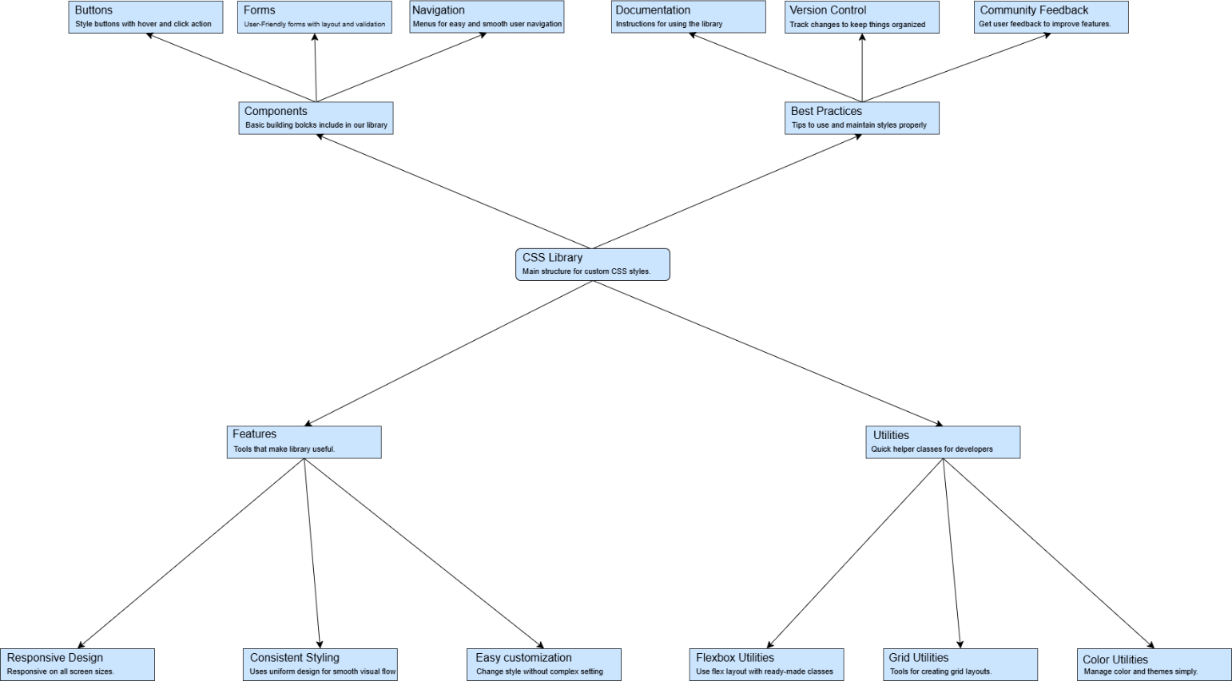

## 2 – 8 June

* + Design wireframes for the portal

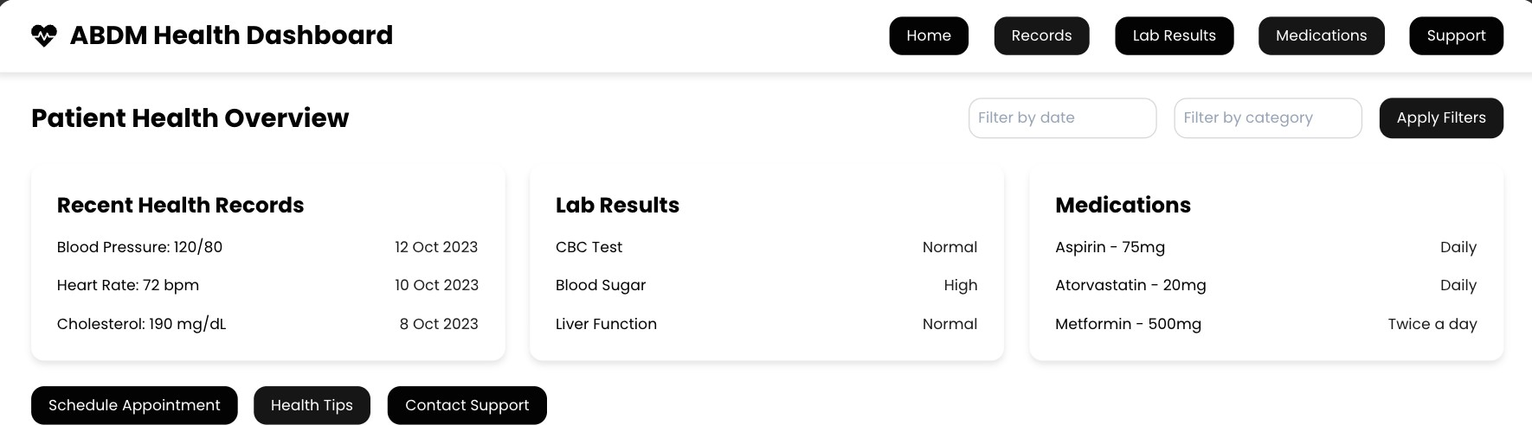

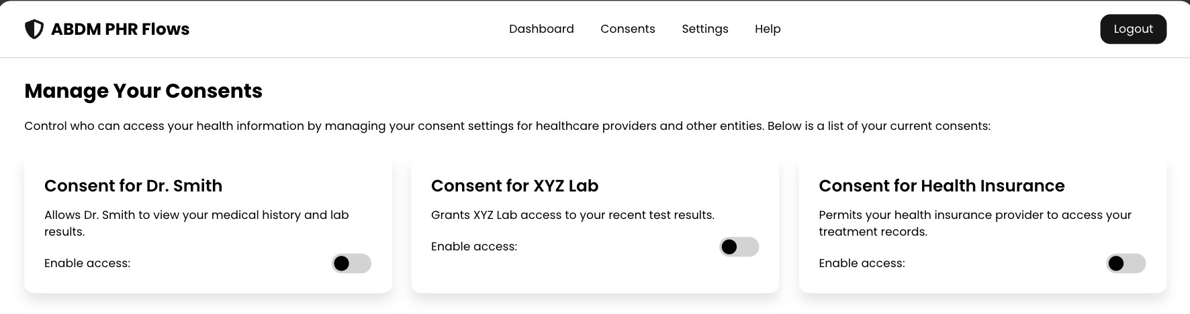

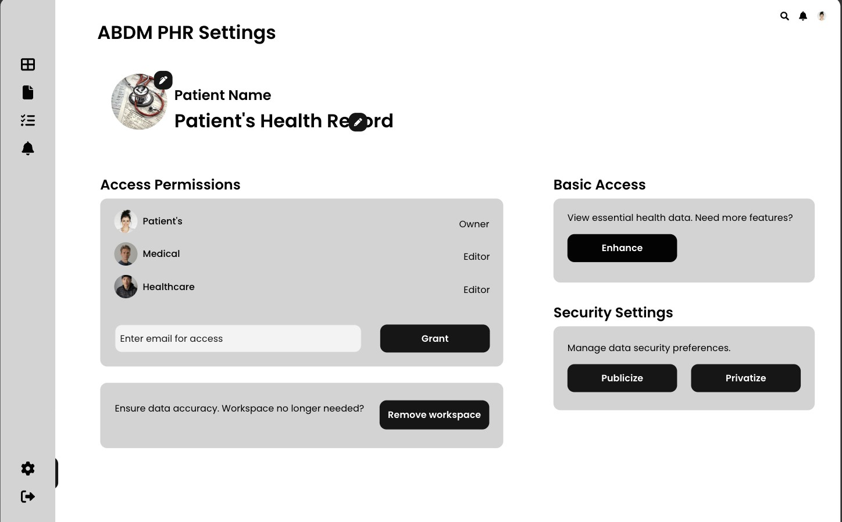

* + Set up frontend framework and CI/CD pipelines
  + Start backend scaffolding for API interactions

## 9 – 22 June

* + Integrate ABDM PHR APIs (record discovery, linking, fetching)
  + Build backend logic for login and consent management

## 23 – 30 June

* + Develop frontend views for records, consents, and profile
  + Hook frontend to backend and test the basic flows

## 1 – 15 July

* + Add validation, error handling, and access controls
  + Run integration tests
  + Implement session and encryption logic

## 16 – 29 July

* + Final polish on frontend: mobile-friendliness, accessibility
  + Test with mock patient data
  + Start writing user and API documentation

## 30 July – 5 August

* + Fix any reported bugs or feedback
  + Finalize deployment and database setup

## 6 – 25 August

* + Wrap up documentation (technical and user-facing)
  + Ensure CI/CD pipelines and security checks are all green
  + Submit deliverables and present the demo

# About We

We're developers who are passionate about building software that solves real-world problems. We care deeply about creating tools that are intuitive, user-friendly, and respectful of user privacy. Over time, we’ve worked across both frontend and backend systems, often integrating them to deliver complete and scalable solutions. This project excites us because it aligns with our interest in digital health and public infrastructure. We're particularly inspired by the impact it can have in helping people across India better manage and access their health data.

# Availability

* Hours per week: 30–35 hours
* Other Commitments: I have final exams in mid-May, but apart from that, I’m fully available—no other jobs or travel during the project duration.

# Past Contributions

[Removed the unwanted padding in the bottom of the patient details page](https://github.com/ohcnetwork/care_fe/commit/d04d47aeabc0c5ab8bc173bae3c7b4fb3a4e640e) [Removed the extra color class from symptoms list](https://github.com/ohcnetwork/care_fe/commit/75d757f49fac159d0fc7a7b45e3aeeeb930b6431)